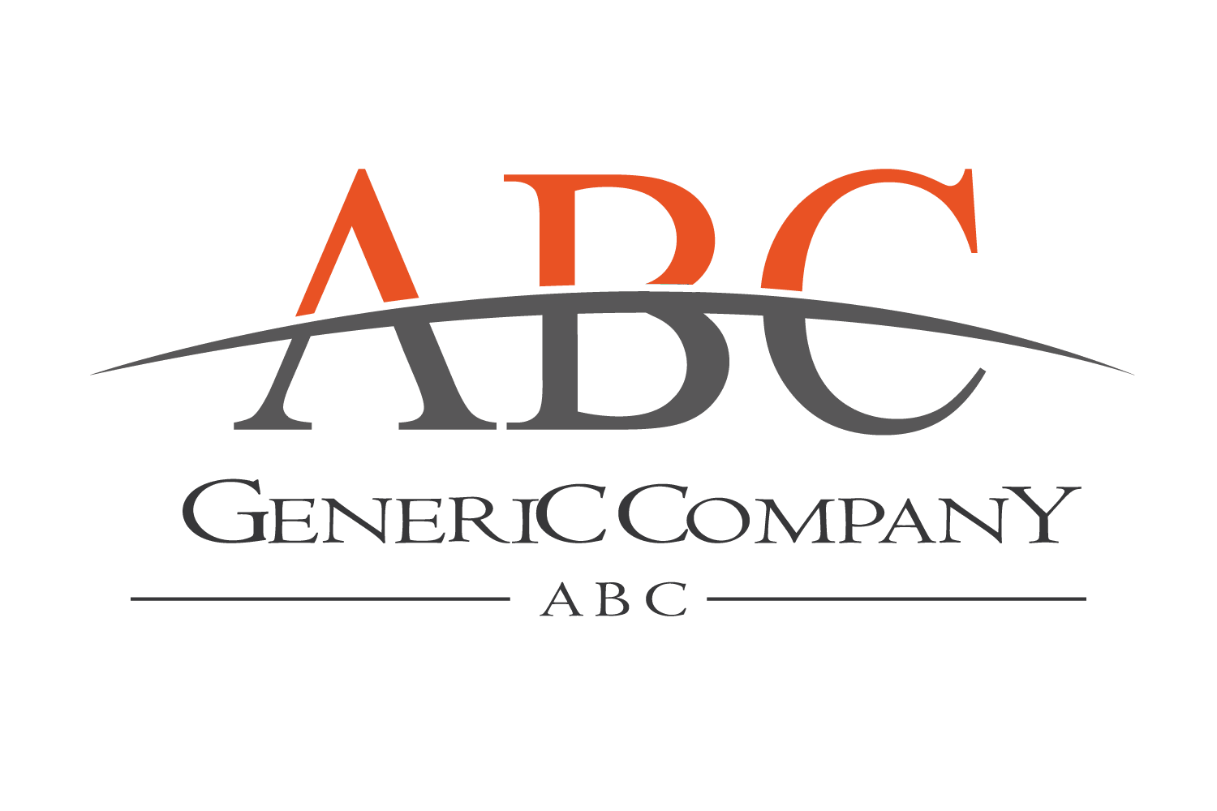
Vocational Support Services
Long Island Campus
Functional Vocational Assessment
Name: Date:
Staff: Service/Program:

Instructions: Complete this form to determine someone’s current vocational capacity. The results will demonstrate strengths as well as areas for improvement. Support Type refers to what kind of support the person is provided to get the specific activity completed. Support Frequency is how often support is provided for a given activity. Grading scale qualifies the person for meeting the expectation of the activity in regard to employment. There are 3 additional zones on the below charts, Acquiring, Reinforcing, and Possesses. Acquiring means the person completes the activity 0-50% of the time with or without support. This category may be for people who are learning something new and benefit from more support. Reinforcing means the person completes this activity 50-70% of the time with or without support. This category is for people who are working towards mastering an activity sometimes they may initiate or be independent but sometimes they don’t and aren’t. The last category, Possesses, means the person more times than not does the activity and is closest to independence.

Support Type | Support Frequency | Grading Scale
1 – Independent  2 – Visual Guide/Cue  3 – Gesture  4 – Verbal Prompt (Cue, Indirect, Direct)  5 – Modeling  6 – Physical Guidance/Assistance | 1 – Independent: without assistance, sporadic  check ins  2 – Occasional: occurring or appearing irregularly  from time to time  3 – Intermittent: stopping and starting at intervals;  coming after a particular time  span; not steady or constant  4 – Frequent:  5 – Continuous | 1 – Exceeds Expectations: Consistently demonstrates skills required for the position. Has emerged as reliable, a leader, and improves the overall team or department  2 – Meets Expectation: Demonstrates the skills required for the position with some exceptions and shows initiative in improving skills  3 – Needs Improvement: Inconsistently demonstrates the skills needed for the position, further development is needed  4 – Unsatisfactory: Not yet demonstrates the skills required or the position and needs to have a formal plan for improving skills, needs additional training

 | Reinforcing  0-50% | Acquiring  50-70% | Possesses  70-100% | Support Type | Support Frequency | Grading Scale | Comments
EMPLOYABILITY SKILLS
Understands the meaning of work, can communicate why we work, benefits of working, motivators for working
Identifies strengths and areas for improvement, communicates needs/accommodations
Follows directions from a respected personnel/figure
Accepts instruction and adheres to requests
Accepts correction or feedback in a positive manner
Willing to correct mistakes or adhere feedback
Completes assigned tasks within allotted time
Can multi-task 1-3 duties
Can multi-task 3-5 duties
Can problem solve by asking the right person for for help
Can problem solve by assessing situation and identifying options
Can problem solve by assessing options and choosing the best one
Understands and adapts to work routines
Produces for 30 minutes at a time
Produces for an hour at a time
Produces for longer than 1 hour
Demonstrates flexibility by adapting to change
Understands professional the use of common work areas (restroom, lounge, break room, cafeteria etc.)
Dresses and grooms sufficiently for the workplace
Takes initiative to help others, or complete their own work
Plans and prioritizes work tasks
Asks Supervisor for clarification or help, as appropriate
COMMUNITY SAFETY
Presents as confident in the community
Can be unattended for >1 hour
Can be unattended for
1-2 hours
Can be unattended for
2-4 hours
Can be unattended for 4+ hours
Is aware of their own personal space
Is aware of their surroundings
Navigates public spaces safely
Is aware of other’s personal space

